**MECE Breakdown Chart**

City Of Events

Games

1. Summer Games
2. Winter Games

Region wise Sports

1. Noc Code
2. Country Name
3. Athelits belong to county

Person Analysis

Sports Analysis

Types of sports

Types of events

Events in different sports

Women’s Events

Men’s Events

Atheletic Discipline

Mixed Events

1. Name
2. Gender
3. Height
4. Weight

Competitor

Olympic Games

Show casting

Participants Name

Medals

Person Name

Games Name

Medals: - Gold

:- Silver

:- Bronze

No Medals

Step-1 MECE break down for the sports analysis problem

Step-2 Solve EDA – Questions using Power-Bi and Excel

Step-3 Create a Dash Board

Step-5 Create a word Document

Step-6 Create a Presentation

Step-7 Create Video of all steps

**Overviews of tables**

**RELATIONSHIP BETWEEN THE TABLES IN POWER BI**

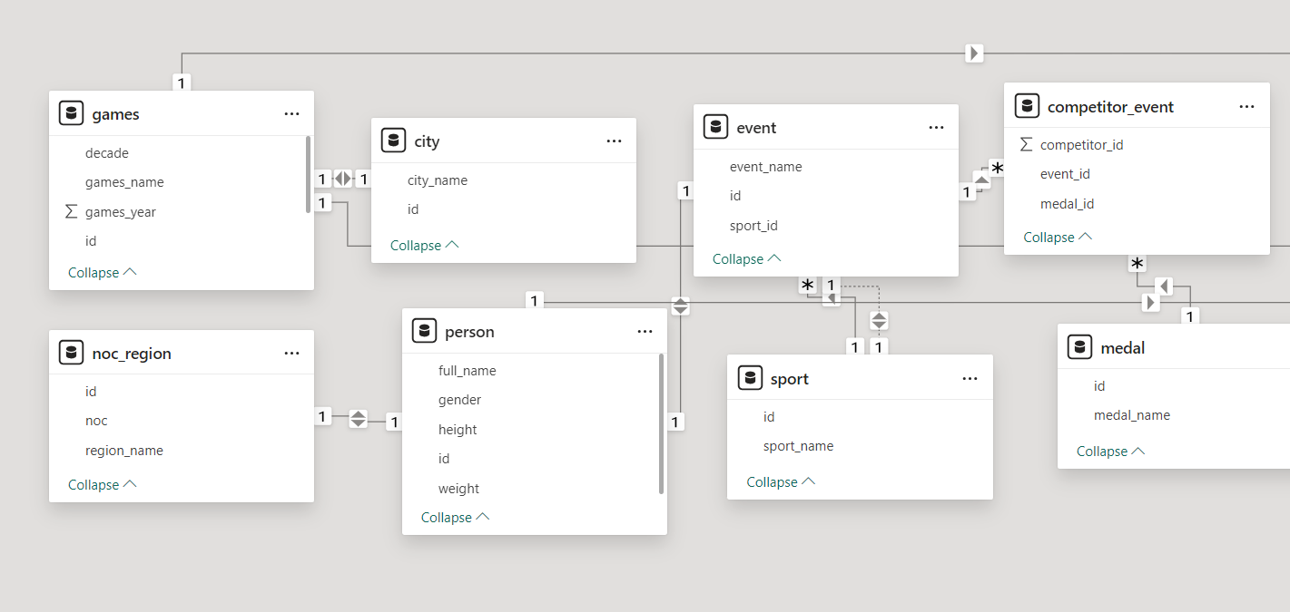

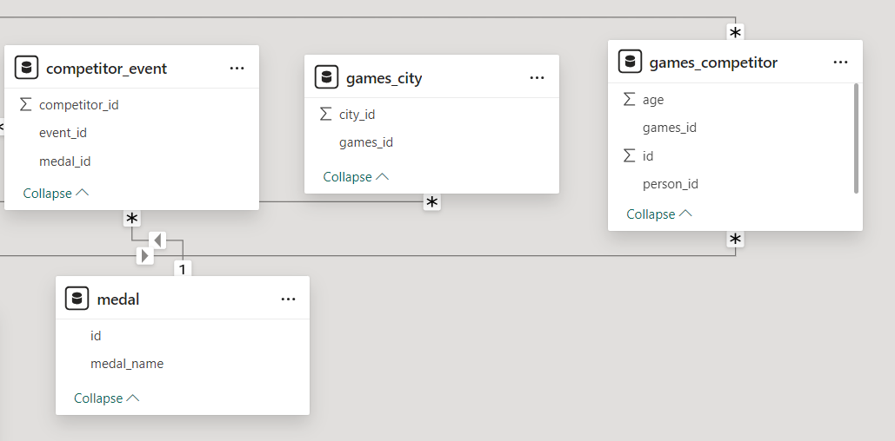

Power Bi

Q.1How many Olympic Games have been held in each season (Summer vs. Winter)?

Ans. 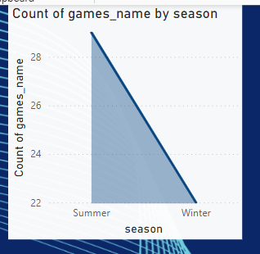

Q.2 What is the distribution of games across different decades?

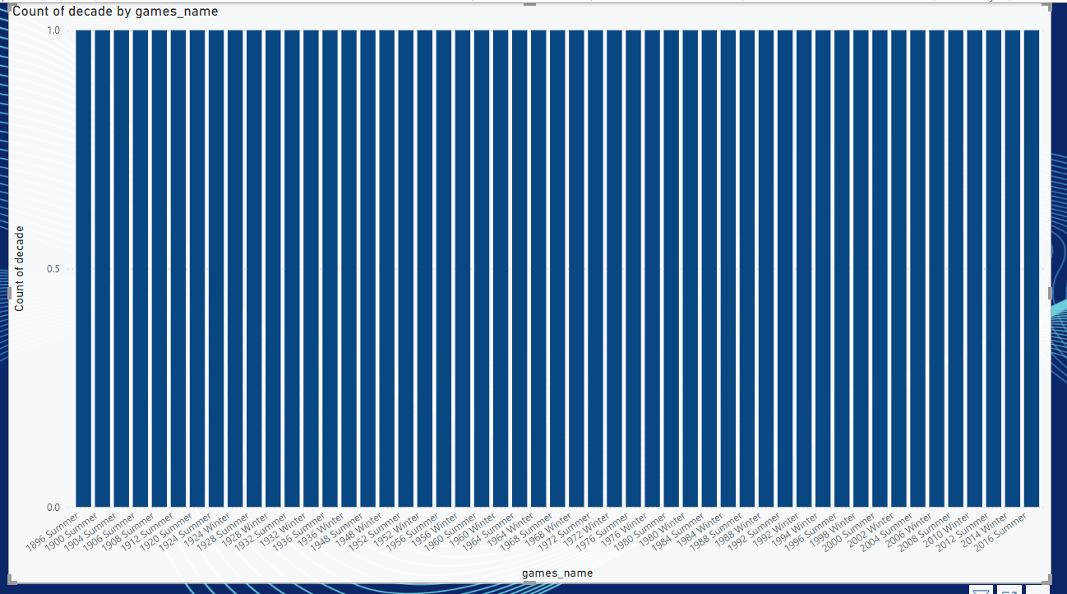

Q.3 Which cities have hosted the most Olympic Games?

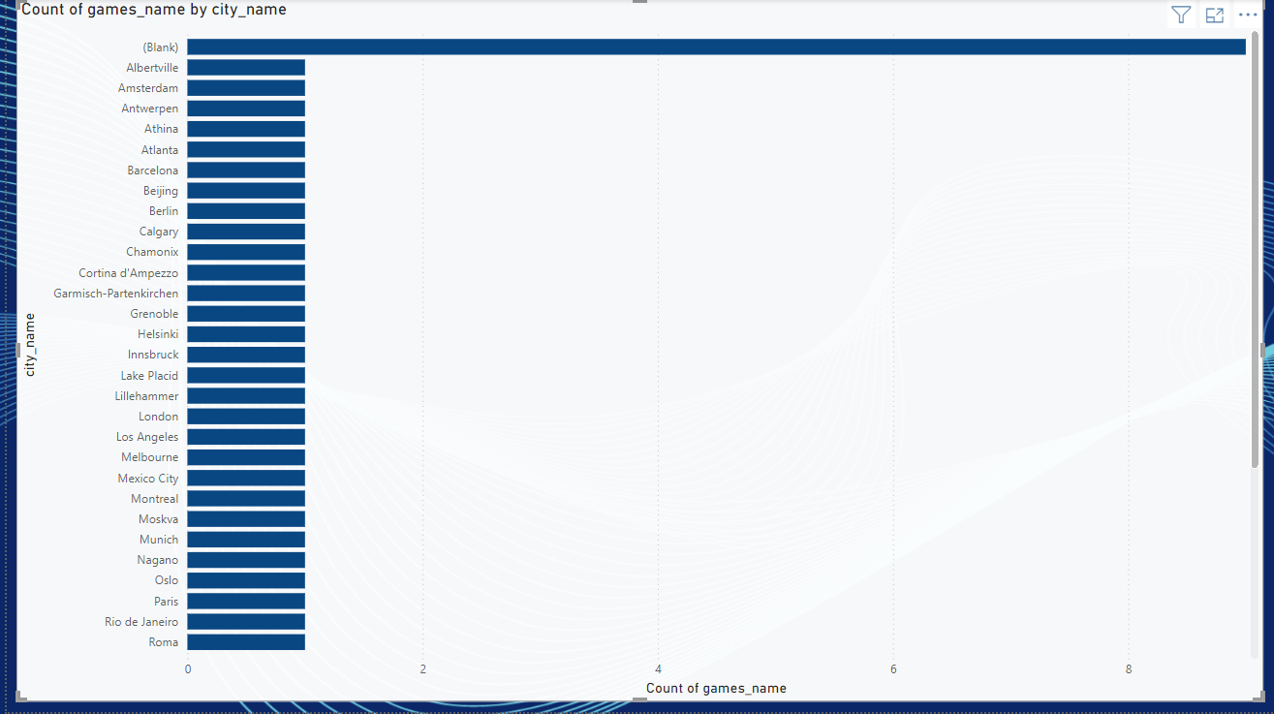

Q.4 What is the distribution of sports between Summer and Winter Olympics?

Ans.4 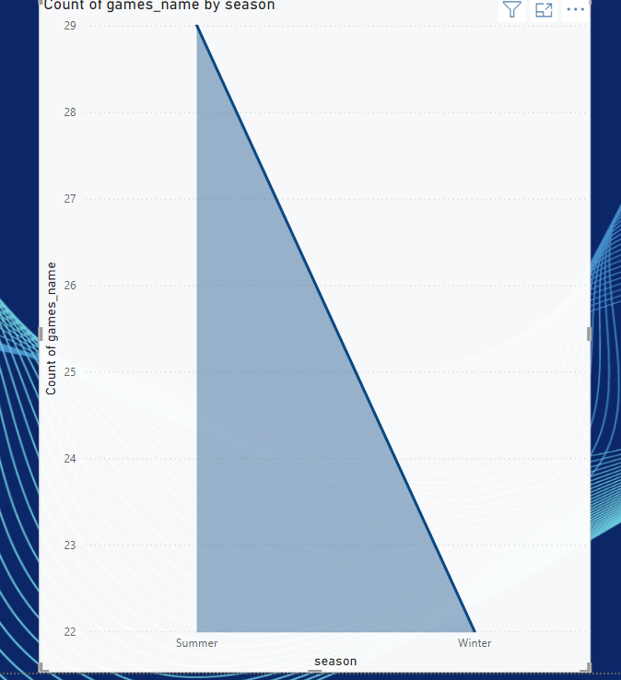

Q.5 Which sports have the highest number of events in the Olympics?

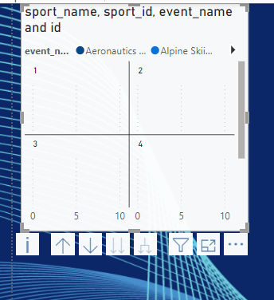

Q.6 How has the participation in each sport evolved over time?

Ans. 